THE HEUGH
LINDISFARNE
NORTHUMBERLAND

Written Scheme of Investigation for an Archaeological Evaluation

Prepared in support of an application to Natural England for SSSI consent

by

The Archaeological Practice Ltd.

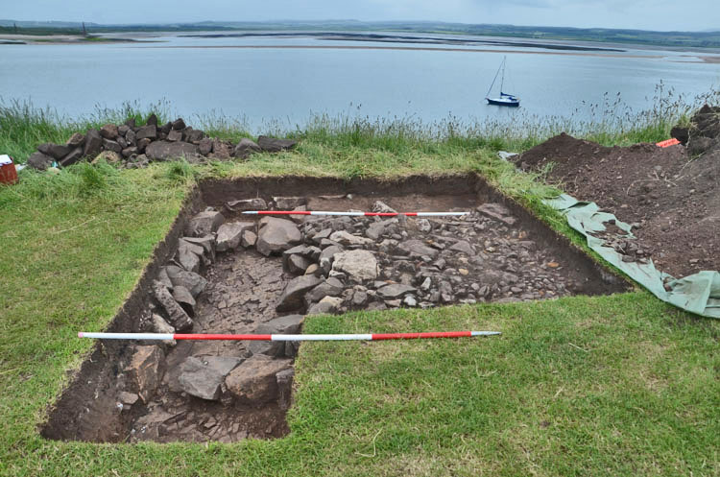

April 2017

CONTENTS

1. INTRODUCTION

2. FIELDWORK METHODOLOGY

3. EXECUTION OF THE SCHEME OF INVESTIGATION

4. TIMETABLE AND STAFFING

ILLUSTRATIONS

Cover: View from the north of build ing remains revealed by excavation in Area 1 in 2016.

Illus. 01: Location of The Heugh.

Illus. 02: O’Sullivan and Young’s Plan (above) based on geophysical survey (below) of perceived archaeological features on The Heugh.

Illus. 03: Excavations on Area 1 (O’Sullivan and Young’s Site C) in 2016.

Illus. 04: View from the south of excavations on Area 2 (O’Sullivan and Young’s Site D) in 2016, showing the remains of flagged building foundations.

Illus. 05: Excavations on Area 2 (O’Sullivan and Young’s Site D) in 2016, showing the remains of building foundations and fragments of dressed stone.

Illus. 06:
The positions of areas proposed to be sampled by excavation in Summer 2017.

.

1. INTRODUCTION AND BACKGROUND

The following represents a project design for archaeological investigations on The Heugh, Lindisfarne.

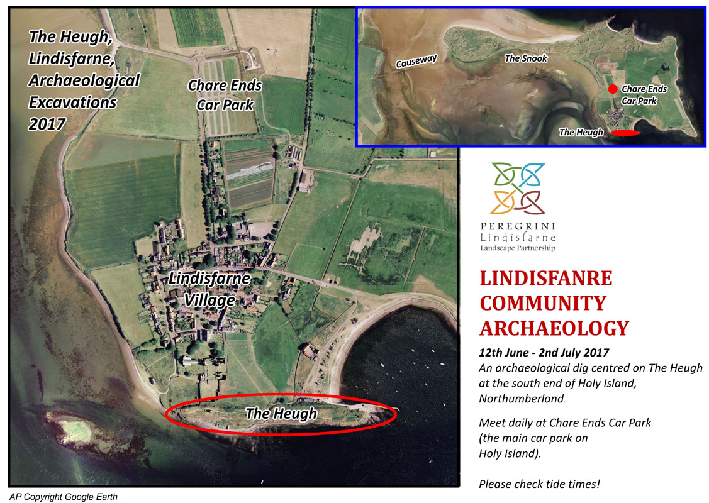

Illus. 01: Location of The Heugh.

1.1 General introduction

The Peregrini Lindisfarne Community Archaeology Project, part of the HLF-funded
Peregrini Lindisfarne Landscape Partnership, is undertaking a range of archaeological investigations on Lindisfarne and the adjacent mainland during 2016 and 2017. The work will be done by local volunteers, directed by the Archaeological Practice Ltd of Newcastle upon Tyne. Participation is open to all, with full training provided as an essential element of all project fieldwork.

Proposed fieldwork for June 2017 includes the evaluation of structures of unknown date on the ridge of high ground to the south the Priory known as the Heugh, a whinstone ridge which extends from the south-west corner of the island, opposite St Cuthbert's Island, to Osborne's fort and the pier on the west side of the harbour entrance. This area has long been suspected as a possible site of buildings associated with the early medieval monastery, active between the 7th and late 9th centuries, but the only buildings currently upstanding there are of much later origin. A key aim of the investigations is to establish the date of buried structures there, and whether or not they are linked with the Anglo-Saxon or medieval monasteries.

The site is not a legally protected scheduled monument, so no consent from Historic
England is required. However, the Heugh lies within the Lindisfarne SSSI so the excavations are subject to the consent of Natural England. It is essential that no ground disturbance takes place other than that specifically approved by Natural England, and all work must comply with the conditions of the Natural England consent.

This document presents background information about the Heugh, together with a detailed methodology for the proposed fieldwork. It should be carefully studed by all prospective volunteers in advance of participation in the project.

1.2 Historic Background

Lindisfarne has a fascinating archaeological heritage extending form prehistoric through to post-medieval and recent times. It is most famous, however, for its early medieval monastery, founded by St Aidan and King Oswald in AD 635. The link with St Cuthbert, and the Lindisfarne Gospels, are particularly well known. However, very little is known for sure about the actual form of the early medieval monastery, though it is assumed to have occupied the same site as the medieval priory, founded in, or shortly before, AD 1122.

The key point to note here is that little is known for sure of the form of the early medieval establishment, but that some authorities have speculated that the remains on the Heugh may have been part of it. A good description of the remains on the Heugh is provided by O’Sullivan and Young (1995, p 46-47), and is reproduced here. Other archaeological remains near the priory have no known history but are also possibly connected with the early monastery. Along the Heugh is a series of small, shallow ruins only clearly visible in late spring when the growth of grass is at its lowest. Some of these were first observed in the late nineteenth century by a casual visitor to the island, and at least one was excavated by Brian Hope-Taylor in the 1960s. The visible features were surveyed by the Lindisfarne Research Project in 1984-5, and a resistivity survey of the whole ridge was also carried out, to see if further evidence existed below ground.

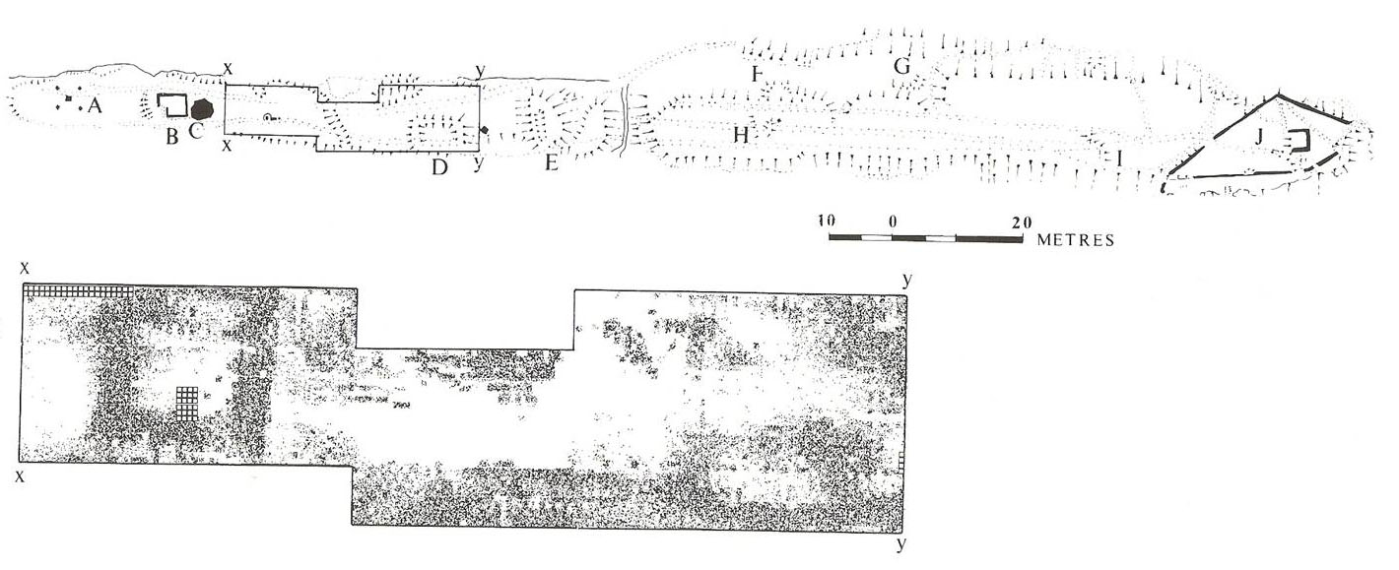

Illus. 02: O’Sullivan and Young’s Plan (above) based on geophysical survey (below) of perceived archaeological features on The Heugh.

At the western end of the Heugh, just west of the early modern ruin known as the ‘chapel’ or ‘lantern chapel’, is a low curved mound (‘A’ on Illus. 02), perhaps simply rubble from the chapel. However, features to the east of this have a more recognisable plan and a more justifiable claim to some antiquity. Just to the east of the present war memorial is a low mound ‘C’, which geophysical resistivity survey suggests is part of a building foundation approximately 15 m (50 ft) square, from which a pathway worn through the rock runs down the north side of the Heugh towards the priory. Further east, at D, the foundations of a small rectangular building, oriented eastwest, are clearly visible. To the east of this again, straddling the centre of the ridge, is a circular mound known as the Cock-pit. A rectangular trench has been cut in this since Blackwell first observed it, probably during the First World War. On the top is a stone crossbase.

To the east of the path which bisects the Heugh a number of other shallow foundations of small rectangular buildings can be seen. Two of these at F and G were partly explored by Hope-Taylor and are aligned east-west. Another, at H, seems to run north-south across the ridge, while further aing, at I, a curved bank may form part of another rather larger east-west building.

Without excavation it is only possible to speculate on the purpose of this series of structures, but they have no obvious place in the arrangenments of the medieval priory or the medieval or early modern village. In Bede’s account of the death of Cuthbert, he makes explicit reference to a watchtower, from which one of the Lindisfarne monks watched for news of Cuthbert’s death. When the saint died (on Inner Farne), those attending him lit two torches, as a prearranged signal that he had passed away, and the monk ‘quickly ran to the church where the whole of the brethren were assembled’. Excellent views of Inner Farne can be obtained from the Heugh, and it is possible that one of the small buildings served the function of a watchtower. Other structures may have served as small chapels or retreats, more in the pattern of a dispersed, Irish-type of monastic complex. They may have been ‘stations’, shrines or stages in a circuit of the monastic precinct associated with a devotional ritual of pilgrimage, known in early Christian Ireland as a turas. There is some indirect evidence for such a pilgrimage route in one of the miracle stories connected with St Cuthbert’s relics. The features on the Heugh and the scattered nature of the early churches and cemeteries is certainly paralleled at Iona, where a church of the eighth century has been discovered underlying the later medieval church of St Ronan, about 1 km south of the abbey.

1.3 Previous Investigations

Other than suspected, but unrecorded, antiquarian activities the only known archaeological work undertaken on the Heugh prior to 2016 was carried out by Brian Hope-Taylor in the 1960s and, non-invasively, by O’Sullivan and Young in the 1980s (see Illus. 02, above).

The first site explored in June 2016 was a squarish anomaly enclosing the current war memorial towards the west end of the ridge, east of the recently refurbished lookout tower. This excavation revealed the foundations of a massive, 2.5 m wide wall constructed of roughly cut facing stones either side of closely-packed, deeply-set cobbles, with smaller cobbles forming an upper surface. There were no significant finds to provide evidence for dating, but the massive walls and form of this structure suggests that it may have been a tower, while its absence from early maps and the lack of mortar in the structure or from the area around it indicates that it is likely to be an ancient structure, perhaps pre-Conquest in origin.

Illus. 03: Excavations on Area 1 (O’Sullivan and Young’s Site C) in 2016.

A second site (Structure D on Illus. 02) explored in June 2016 a little further to the east, in the area between the current lookout tower and shipping beacon, revealed more building foundations, this time in the form of massive limestone blocks forming the base of a north-south wall between 1 m and 1.2 m wide, with an apparent, narrower east-west return at the north end. Numerous smaller, squared stone blocks bearing crude chisel marks, showing that they had been shaped as building stones, were found in deposits above these foundation stones, but no other finds to indicate their date of origin. However, the nature of these remains, absence of mortar bonding material and documentary corroboration suggests that they are of early origin. Peter Ryder, historic buildings consultant to the project, supports this view. Excavations carried out by Hope-Taylor just to the east in 1962, probably on the east end of the same structure, concluded that the building concerned was a church, although the excavator does not appear to have reached foundation level and the evidence for his interpretation is not recorded. Only further excavation will be able to confirm this interpretation.

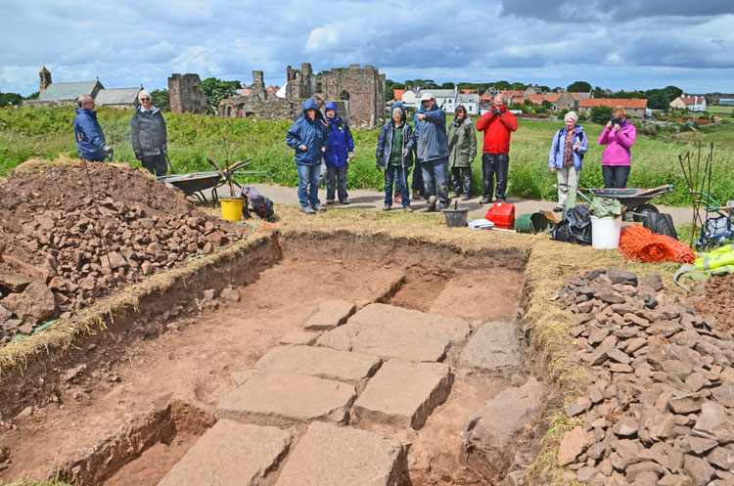

Illus. 04: Excavations on Area 2 (O’Sullivan and Young’s
Site D) in 2016, showing the remains of building foundations.

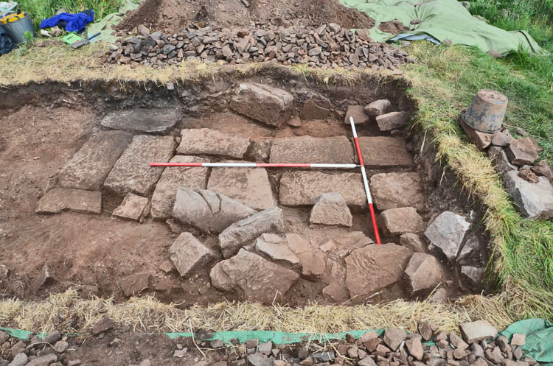

Illus. 05: Excavations on Area 2 (O’Sullivan and Young’s Site D)
in 2016, showing the remains of building foundations and
fragments of dressed stone.

1.4 Aims and objectives of fieldwork in 2017

This project is small in scale and has one general aim - to characterise the nature and condition of the structures on the Heugh. A particular aim is to try and establish the date of the various structures, in order to ascertain whether they may relate in some way to the early medieval monastery or the medieval priory.

Questions which the project may help to address include the following:

What is the condition of buried deposits and how do these buried remains relate to the visible earthworks?

What was the original nature of the structures on the Heugh, and did they change through time?

Is there any evidence for early activity on the Heugh? Although it is unlikely that evidence for early structures will be found in the proposed trenches, it is quite possible that some stray finds, e.g. lithics, could be recovered.

Is there any evidence for activity on the Heugh in post-medieval times?

Are the sites being damaged in any way, for example through footpath erosion, and if so, can practical suggestions be made as to their future management?

What potential do these sites offer for further investigation?

Is there potential for consolidation and public interpretation of one or more of the sites investigated?

A further key objective is to provide the opportunity for local volunteers to learn techniques of archaeological excavation. Some volunteers will be experienced, having participated in other community archaeology projects, but others will have no previous experience. Full training and constant professional supervision will be constantly available throughout the project, and volunteers will be encouraged to take part in all aspects of fieldwork, including recording.

2. TRENCH LOCATIONS AND PURPOSE

As noted above, the proposed trenches are located in order to investigate and evaluate four structures, or supposed structures, on the Heugh, two of which were also investigated in 2016 and had previously been partially evaluated by undertaken by Brian Hope-Taylor. The final form of each trench will be dependent on decisions made once work is in progress, and plans must be to an extent flexible at this stage.

The amount of work actually completed will be dependent on factors such as the number of volunteers attending, the complexity of the archaeological remains encountered, and the weather.

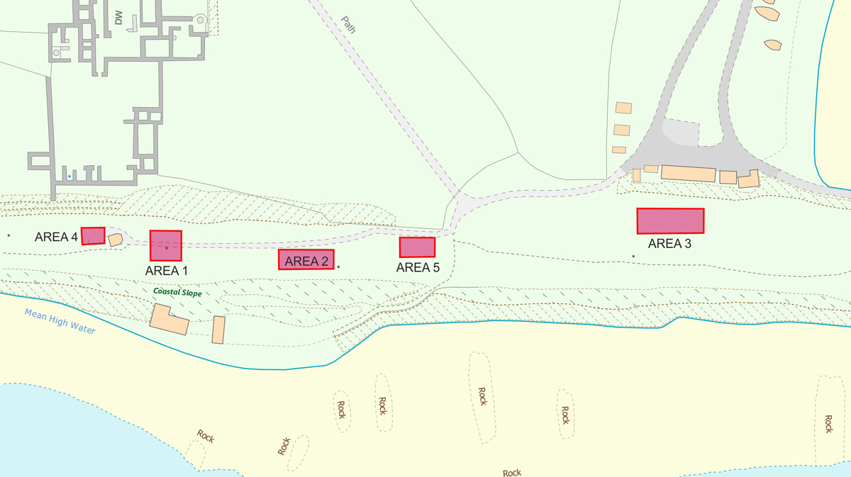

Illus. 06:
The positions of areas proposed to be sampled by excavation in Summer 2017.

It is proposed to excavate in four locations (Areas 1-4 – see Illus. 06, above), with an additional site held in reserve, as set out below. These will carefully located so as to cause no inconvenience to other visitors to the Heugh.

AREA 1.
To investigate the geophysical anomaly around the war memorial; structure C on Illus. 02. This structure was examined in 2016 but no secure dating evidence was retrieved, so a principal aim of the 2017 excavation will be to provide evidence for dating this structure, as well as to confirm its scale and state of survival.

AREA 2.
To reinvestigate Structure ‘D’ on Illus. 02. This feature was also partially examined in 2017, but no secure dating evidence was retrieved. In 2017 the excavation will be located to enable detailed recording of Hope-Taylor’s excavation (presumed to be at the opposite, east end to the 2017 excavations), and to sample previously disturbed features and samples.

AREA 3.
To investigate the area between Structures F/H and G on Illus. 02 by means of a c10 x 2 metres trench. Located to enable detailed recording of Hope-Taylor’s excavation here, and to extend his trench to enable the investigation and sampling of previously undisturbed features and samples.

AREA 4.
To investigate the interior of the structure known as the Lantern Chapel, by means of a trench measuring up to 7 x 3 metres.This structure is the nlly one appearing on early maps of the area but nothing is known abut it, although it is presumed to be a look-out or early lighthouse.

Possible further trenches
Depending on available resources, feature E (AREA 5 on Illus. 02) may also be investigated by means of a small evaluation trench. In addition to this, possible work on Osborn’s Fort will require SMC as well as SSSI consent and will be considered in an amended version of this WSI or in a separate document.

All trenches will be excavated to reveal and appropriately record features of archaeological significance. The position and initial dimensions of the trenches will be determined by existing knowledge of the position and extent of archaeological remains known to exist in the relevant locations. The trenches may then be expanded depending on available resources and the nature of finds made within them.

2. FIELDWORK METHODOLOGY

2.1 General

2.1.1 The Field Investigation will be carried out by means of Archaeological Excavation.

2.1.2 All work will be carried out in compliance with the codes of practice of the Institute of Field Archaeologists (IFA) and will follow the IFA Standard and Guidance for Archaeological Excavations.

2.1.3 All archaeological staff will be suitably qualified and experienced for their project roles. Before commencement of work they will have been made aware of what work is required under the specification and they will understand the aims and methodologies of the project.

2.2 Excavation

2.2.1 The trenches will be excavated in the positions indicated in Illus. 06 (above). Excavation, recording and sampling procedures will be undertaken using the strategies indicated below.

2.2.2 The setting out of the trenches will be undertaken by the archaeological contractor.

2.2.3 The excavation will be carried out manually by archaeologically competent staff and by volunteers under continuous archaeological supervision.

2.2.4 The topsoil or recent overburden will be removed in successive level spits down to the first significant archaeological horizon or the natural subsoil, whichever is encountered first.

2.2.5 Turf and spoil will be kept close-by and rapidly backfilled into the trenches at the conclusion of this work. The turf to be removed from the sites in question is not considered particularly species rich or as sensitive as the flora of the south-facing cliff face to the south of the archaeological sites on the Heugh plateau, but care will nevertheless be taken to ensure effective and successful reinstatement following the recording of archaeological remains. Watering of the turn may be necessary during storage in dry conditions, but advice will be taken from Natural England on this issue.

2.2.6 All faces of the trench that require examination or recording, and the top of the first significant archaeological horizon or the natural subsoil, will be cleaned sufficiently to establish the presence or absence of archaeological remains

2.2.7 In the event that small discrete archaeological features are revealed, including but not limited to postholes and pits, the trench will be expanded either side of the feature by a machine bucket width as standard. If further additional trench expansion is required, this will be carried out following discussions with the Assistant County Archaeologist and at that stage the contingency allowance can be used.

2.2.8 Sufficient of the archaeological features and deposits identified will be excavated by hand through a sampling procedure to enable their date, nature, extent and condition to be described. Pits and postholes will normally be sampled by half-sectioning although some features may require complete excavation. Linear features will be sectioned as appropriate.

The sampling procedure will typically comprise:
50% of every discrete feature
25% of the area of linear/curvilinear features with a non-uniform fill
10% of the area of linear/curvilinear features with a uniform fill

However, in the case of certain features, particularly those of a complex nature, it may be deemed, in consultation with the Northumberland Assistant County Archaeologist, that sufficient information has been derived from exposure of the feature and further investigation would be better deferred to a subsequent stage, involving mitigation excavation, where such features can be examined in conjunction with adjacent related features.

2.3 Archaeological Recording

2.3.1 Archaeological stratigraphy revealed by excavation will be recorded by the following means:

2.3.2 Written descriptions. Each archaeological context will be recorded on a pro-forma sheet. Minimum recorded details will consist of the following: a unique identifier; an objective description which includes measurements of extent and details of colour and composition; an interpretative estimate of function, clearly identified as such; the identifiers of related contexts and a description of the relationship with such contexts (for preference, executed as a mini Harris matrix); references to other recording media in which representations of the context are held (plans, sections, photographs).

2.3.3 Measured illustrations. The drawn record from the site will include a representative selection of long sections from the excavations that clearly allow the nature and depth and any significant changes in the deposits recorded to be demonstrated. Detail plans and sectional profiles of archaeological features will be at appropriate scales (1:20 or 1:10). Archaeological contexts will be referenced by their unique identifiers. All illustrations will be properly identified, scaled and referenced to the site survey control.

2.3.4 Photographs. Digital photographs will be taken for purposes of record. A system will be used for identifying the archaeological features photographed.

2.3.5 All processing, storage and conservation of finds will be carried out in compliance with the relevant IFA and UKIC (United Kingdom Institute of Conservation) guidelines.

2.3.6 Portable remains will be removed by hand; all artifacts encountered will be recovered.

2.3.7 The potential requirement for specialist analyses (see below) is an unavoidable risk in all such excavations. The scientific investigation of any features/deposits which are considered significant will be undertaken as a non-negotiable part of this programme. Any such analyses would be carried out by specialists and priced to the client on a costs only basis (see Contingencies in the Project Costing).

2.4 Analysis and Reporting of Recovered Data

2.4.1 Following the completion of the Field Investigation and before any of the post-excavation work is commenced, an archive (the Site Archive) containing all the data gathered during fieldwork will be prepared. No archive will be required if the results of the evaluation are wholly negative

2.4.2 Following completion of the Field Investigation, a full report will be prepared collating and synthesizing the structural, artefactual and environmental data relating to each agreed constituent part of the evaluation works.

2.5 Environmental Sampling and Scientific Dating

2.5.1 The investigations will be undertaken in a manner consistent with MoRPHE EH 2006 and PPN 3 and with “Archaeological Science at PPG16 Interventions: Best Practice for Curators and Commissioning Archaeologists”, English Heritage, 2003.

2.5.2 The following strategy for environmental sampling will be confirmed with HE Regional Science Advisor is Don O'Meara (0191 3341137 or 07713 400387) before the excavation begins.

2.5.3 Deposits/fills with potential for environmental evidence will be assessed by taking up to two bulk samples of 30 litres from any context selected for analysis by the excavator from suitable (i.e. uncontaminated) deposits. Deposits/fills totalling less than 30 litres in volume will be sampled in their entirety. Six of the collected samples which are judged to be most suitable on grounds of being derived from uncontaminated and reasonably well-dated deposits and/or recognisable features will be selected for full analysis, reporting and publication. The proposed processing strategy will be discussed with NCC Conservation Team (and if necessary the HE Regional Science Adviser) before processing. This is to ensure that only work necessary to inform the objectives of the evaluation is undertaken. The same principle would apply to any other sampling with potential to generate additional cost.

2.5.4 Any significant animal bone assemblages, which can be used to explore themes such as hunting and fowling, fishing, plant use and trade, seasonality, diet, age structures, farrowing areas, species ratios, local environment will be assessed by a recognised specialist.

2.5.5 Waterlogged organic materials should be dealt with following recommendations in Guidelines for the care of waterlogged archaeological leather (English Heritage and Archaeological Leather Group 1995).

2.5.6 Deposits will be assessed for their potential for radiocarbon, archaeomagnetic (guidance is available in the Centre for Archaeology Guideline on Archaeometallurgy 2001) and Optically Stimulated Luminescence dating. As well as providing information on construction techniques, timbers will be assessed for their potential for dendrochronology dating, in which case sampling will follow procedures in Dendrochronology: guidelines on producing and interpreting dendrochronological dates (Hillam 1998) and Guidelines on the recording, sampling, conservation and curation of waterlogged wood (R. Brunning 1996). A maximum of 5 samples of material suitable for dating by scientific means (eg: Radiocarbon, Luminescence, Remnant Magnetism, etc.) will be collected.

2.5.7 Information on the nature and history of the site, aims and objectives of the project, summary of archaeological results, context types and stratigraphic relationships, phase and dating information, sampling and processing methods, sample locations, preservation conditions, residuality/contamination, etc. will be provided with each sample submitted for analysis.

2.5.8 Laboratory processing of samples shall only be undertaken if deposits are found to be reasonably well dated, or linked to recognisable features and from contexts the derivation of which can be understood with a degree of confidence.

2.5.9 Human remains will be treated with care, dignity and respect, in full compliance with the relevant legislation (essentially the Burial Act 1857) and local environmental health concerns. If found, human remains will be left in-situ, covered and protected, and the church authorities and County Archaeologist informed. If it is agreed that removal of the remains is essential, they will be removed and stored with appropriate care and reburied in a location to be determined with the church authorities. Any analysis of the osteological material will take place according to published guidelines, Human Remains from Archaeological Sites, Guidelines for producing assessment documents and analytical reports (English Heritage 2002).

2.5.10 If anything is found which could be Treasure, under the Treasure Act 1996, it is a legal requirement to report it to the local coroner within 14 days of discovery. The Archaeological Practice Ltd. will comply with the procedures set out in The Treasure Act 1996. Any treasure will be reported to the coroner and to The Portable Antiquities Scheme Finds Liaison Officers, Lauren Proctor/Ellie Cox (03000 267012 or lauren.proctor@durham.gov.uk, ellie.cox@durham.gov.uk) for guidance on the Treasure Act procedures. Treasure is defined as the following:

- Any metallic object, other than a coin, provided that at least 10% by weight of metal is precious metal and that is at least 300 years old when found
- Any group of two or more metallic objects of any composition of prehistoric date that come from the same find
- All coins from the same find provided that they are at least 300 years old when found, but if the coins contain less than 10% gold or silver there must be at least ten
- Any object, whatever it is made of, that is found in the same place as, or had previously been together with, another object that is Treasure
- Any object that would previously have been treasure trove, but does not fall within the specific categories given above. Only objects that are less than 300 years old, that are made substantially of gold or silver, that have been deliberately hidden with the intention of recovery and whose owners or heirs are unknown will come into this category

2.5 Production of Final Report

2.6.1 Copies of the report will be provided within two months of the completion of fieldwork to the Client and Northumberland County Assistant Archaeologist. An additional digital copy of the report will be lodged with the Northumberland County HER.

2.6.2 Two bound and collated copies of the report will be provided. Each will be bound, with each page and heading numbered. Any further copies required will be produced electronically. The report will include as a minimum the following:

A summary statement of methodologies used.
A location plan of the site and any significant discoveries made.
Plans and sections of any archaeological discoveries of note.
A summary statement of results.
Conclusions
Recommendations

2.6.3 Arrangements will be made to deposit the Site Archive (including Finds) and the Research Archive with the designated repository within 6 months of the end of the fieldwork. Digital data, in particular a selection of important site photographs will be archived with ADS at the University of York.

2.6.4 Summary reports of the project will be prepared, if necessary, for inclusion in the appropriate Notices, Annual Reviews, Reports, etc.

2.6.5 An entry for inclusion in the Northumberland County Heritage Environment Record will be prepared and submitted.

2.6.6 OASIS
The Archaeological Contractor will complete the online form for the Online Access to Index of Archaeological Investigations Project (OASIS), following consultation with the Northumberland HER Officer. The Contractor agrees to the procedure whereby the information on the form will be placed in the public domain on the OASIS website, following submission to or incorporation of the final report into the Northumberland County HER.

3. TIMETABLE AND PERSONNEL

3.1 Timetable

It is proposed to complete the evaluation over the period between 12th June
and 2nd July. Following the completion of on-site work, further time will be required to produce an appropriately illustrated report on the work, as detailed above.

3.2 Personnel

Archaeological Practice  Project Manager: R Carlton  Project Archaeologists:  Marc Johnstone, Michael Parsons | Sub-Contractors  Archaeological Services Univerity of Durham (Environmental remains)  Jenny Vaughan (Medieval and post-medieval pottery)  Lindsay Allason-Jones (Roman small finds)  Dr Rob Young (Prehistoric artifacts)

Fieldwork will be largely undertaken by volunteers, under constant professional direction and supervision. The professional project team will consist of the following individuals, with analysis and writing-up being largely carried out by Richard Carlton. These personnel will be assisted by Rob Young and Paul Frodsham, both previously Northumberland National Park Archaeologists with much experience of directing fieldwork projects involving volunteers in North Northumberland and elsewhere.

Richard Carlton
Richard Carlton is a Director of the Archaeological Practice Ltd. with responsibilities
including project management, fieldwork and desktop research. He has a wide range of research and recording experience accumulated over the last two decades, and has completed many hundreds of professional archaeological reports, including evaluation excavations and historic building records, covering sites and monuments of all periods in northern England and lowland Scotland. He has also directed several community projects involving hundreds of volunteers.

Marc Johnstone
Marc Johnstone has been an associate of the Archaeological Practice since 2007 and is now an employee with particular interests as an Archaeological Computing Specialist and all-round field archaeologist. Following graduation with a BA in Archaeology and an MSc in Internet Archaeology from Newcastle University, Marc established his own heritage interpretation company (Heritage Media), working on a number of high profile, research projects.

Michael Parsons
Michael Parsons is a highly experienced archaeological excavator who has worked
intermittently for the Archaeological Practice since 2006. He has wide experience of
excavating and recording on a wide range of sites from all periods, and has worked with the Archaeological Practice on Roman, medieval and post-medieval remains. He has just completed a second season of excavation on the Roman fort at Maryport, Cumbria, where he worked on secondment for the University of Newcastle, performing roles of supervisor and excavator.

Peter Ryder
Additional specialist advice will be taken from Peter Ryder on building remains
encountered. Peter Ryder is a nationally renowned expert on the historic buildings of northern Britain, with particular interests including medieval churches, medieval and later defensible buildings, Non-Conformist chapels and historic farm buildings. Since coming to Northumberland in the 1970s as part of the listed buildings team, he has completed over 700 reports on historic buildings for clients in northern England, principally in Northumberland and Cumbria, and has also published widely on themes as diverse as medieval churches in West Yorkshire, medieval grave covers of northern England and bastles in the northern counties. Since 2003 he has worked as an associate of the Archaeological Practice Ltd., contributing to over 100 reports for that organisation. Further appropriate specialists will be contracted if necessary, depending on the results of the excavation.

4. HEALTH AND SAFETY

Full consideration will be given to matters of health and safety throughout this project. A comprehensive risk assessment will be produced prior to the commencement of work, andthis will be revised if appropriate as the project progresses.A health and safety induction will be given to all volunteers at project start-up, and all will be required to read the comprehensive risk assesment which will be kept on site and which all volunteers partaking in the project will be required to sign, stating that they have read and understood it and that they will abide by its terms.

All work will be undertaken in full accordance with the Archaeological Practice’s health and safety policy, which conforms to the provisions of the Standing Conference of Archaeological Unit Managers (SCAUM) Health and Safety Manual. The staff of the Archaeological Practice are fully trained with regard to health and safety, including first aid, manual handling, cable detection, site safety and risk assessment.

All Archaeological Practice staff are supplied with appropriate safety clothing and equipment, and advice as to appropriate clothing and equipment will be provided to volunteers.

5. PUBLICITY AND OUTREACH

Depending on the results, there may well be much public interest in this project. It is not intended to generate any advance publicity for the work, but if the results appear to be interesting once the work is underway then consideration will be given to issuing a press release and perhaps holding an open day for the media. Any such decisions will only be taken in liaison with Peregrini Lindisfarne project officers, and it is envisaged that any press releases will be issued through the project. Natural England will also be invited to contribute to the production of any press release and to participate in any media work associated with the project.

Once the work is complete, consideration will be given to the issuing of a press release covering the results.

At an appropriate time, a lecture will be given for the benefit of local residents, perhaps linked to a guided walk around the site.

The full report on the project, along with an illustrated summary, will eventually be made generally available via the Peregrini Lindisfarne project website.

